Statement of Cash Flow
Institution Affiliation
Students’ Name
Date of Submission

Statement of Cash Flow
The development and components of the statement of cash flows.
The cash flow statement had not existed like the statement of income and the balance sheet until 1988 when it was first prepared in the United States (Davis 2015). It was first prepared by the Northern Central Railroad showing their transactions that contained highlights of the cash receipts during that particular year. The summary issued was then named as a statement of cash flow. According to Davis (2015), the main reason why it was developed was to trace the flow of money in organizations to bring accountability and transparency. Also, there was high tension in measuring the value of assets and liabilities. This was seen like creating confusion in the flow of money and the development of the cash flow statement was seen as the only means to control the flow of money as well as examining the net changes in working capital of the organization.
Up to date cash flow statement is still a useful finance tool of tracing the flow of money as it mainly focuses on the cash inflows and cash outflows during a specific time like a year. According to Arnold et al. (2018), it is useful especially by providing analysis of the liquidity and long-term solvency of an organization. It has various components that ensure a clear flow of cash, and they include; investment activities, operations activities as well as financing activities.
- Operating activities.
Every organization or a company usually get involved in a day to day activity known as operations. Therefore, the net cash that is received or paid out from the daily operations is known as the operations cash flow. Operations cash flow is a significant aspect in cash flow as it shows clearly to the analysis expert about the feasibility of entities from business operations. It is believed that, in the long run, operations cash flow must display information about the flow of cash in an organization or company for it to be solvent to provide outflows from other activities like investment and financing activities (Livnat & Zarowin 1990). It has some common elements that are either added or subtracted to get the net operating cash flows. These elements are; cash payments made to suppliers and employees, receipts from suppliers and it is always added, others like payment of interest and income taxes are deducted. But all these elements are added together to find the net operating activities.
The table below shows how net cash flow from operating activities is calculated from the given elements.
Cash Flows from Operating Activities | $ | $
Cash Receipts from Customers | 9,500
Cash Paid to Suppliers and Employees | (2,000)
Cash generated from operations (Add) | 7,500
Interest Paid | (2,000)
Income Taxes Paid | (3,000)
Net Cash Flows From Operating Activities. |  | 2,500

- Investing activities
According to Livnat & Zarowin (1990), investing in activities is another component of the financial cash flows. Its' cash flow contains outflow from the purchases of long term assets like buildings, land, and equipment. It also has cash inflows from business sales, sale of assets and securities of a company or organization. In most organizations and companies, the cash flow from investment activities is usually recorded as cash outflows because most of them choose to make long term investments for the growth and future operations of the company. For example, a company can decide to invest more on their assets with ($100,000), there can also be proceeds from the sales of equipment of $50,000, and they are always added, and lastly, we can have dividends received of $20,000 which is also added. This can be clearly illustrated in the table below to show how investment activities are recorded in cash flow statement.
Cash Flows from Investment Activities | $ | $
Investments on assets | (100,000)
Sales of equipment | 50,000
Dividends receipts | 20,000
Net cash Flow from Investment activities |  | 30,000

- Financing activities
The third component of the financial cash flow statement is financing activities. It involves the outflow of cash to the investors, such as bondholders of the company or organization through interest and dividends repayments to shareholders. Cash inflows from investing activities occur in the sales of the company's bonds or when stock equity is issued. However, in financing activities, most company's face massive cash outflows than inflows because they issue bonds and stocks in most cases (Livnat & Zarowin 1990). Financing activities only take into consideration repayments, borrowings and raising money through purchasing back shares, issuance, borrowing cash and making dividends repayments. In this case, anything that is about loan falls in the financing activities. At the same time, any money received is positive cash flow as cash is added to the company and, any payments made are negative cash flow because money gets out of the company (Ormiston & Fraser 2007). For example, the company might pay its dividends with ($5,000), sale its stock at $10,000, and increase its debts by $50,000. In such a case, the net financing activity can be calculated by adding all these variables, as shown in the table below.
Cash Flows from Financing Activities | $ | $
Dividends Paid | (5,000)
Sale of Stock | 10,000
Increase in Debts | 50,000
Net cash Flow from Financing activities |  | 55,000

Alternative methods of developing and presenting the cash flow statements
Bradbury (2011) proposed that there are two approaches of making and presenting statements of cash flow. They include; indirect and direct approaches. Both methods are efficient, but many companies use indirect method but what is more important is that at the end point, the cash balances should always be equivalent to the amount shown on the income statement or balance sheet. When using the direct approach to prepare cash flows, it indicates the net cash from the operations activities as well as repayments and all cash receipts from business operations (Krishnan & Largay III 2000). For instance, cash collected from customers and any dividend or interest the company receives are examples of cash receipts. On the other side, cash paid to suppliers, employees, and interest paid on loan are examples of cash payments. In the indirect method, the net income appears first from the income statement in the operating activities. Adjustments on net income are made using the non- cash variables, thus affecting the income statement, depreciation is one of the adjustments. Other variables that are adjusted are losses and gains from the sale of assets.
The direct method also poses some cash flow effects on the components of cash flow by increasing and reducing cash accounts (Krishnan & Largay III 2000). For instance, when using the direct method, cash flow from the operating activities shows the net cash received or given out at a particular time. It entails subtracting cash sales of the operating expenses that used cash. It does not have either increase or decrease cash account. In financing activities, it involves the analysis of the stockholders' equity and long term liability accounts. However, in financing activities, most company’s face cash outflows than inflows because they issue bonds and stocks in most cases, and these reduce their cash accounts. The last effect is on the investing activities. The indirect method still poses a significant impact by reducing cash accounts in investing activities. You find that the cash flow from most of the companies are usually cash outflows because they choose to make long term investments for the growth and future operations of the company.
The first picture below shows Wal-mart Inc. stores statement of cash flow from 2014 to 2016. The second picture shows the statement of cash flow of Apple Inc Company from the year 2016 to 2018.
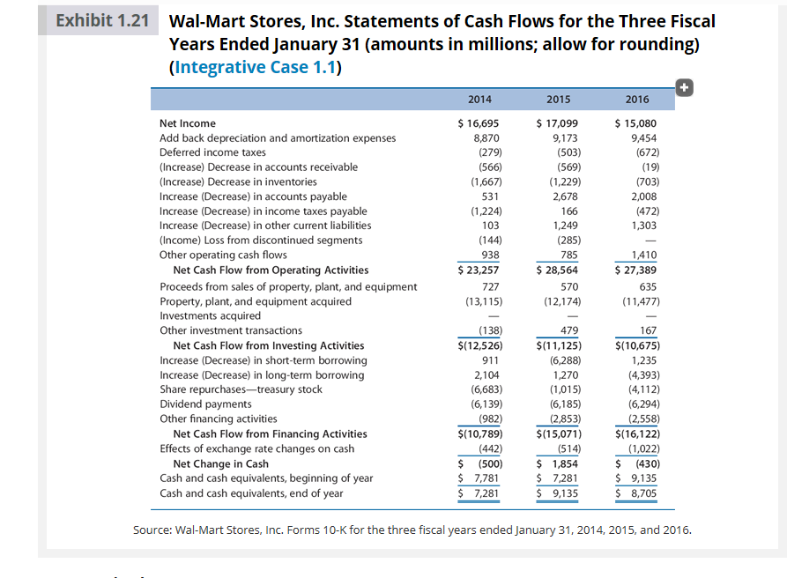
Source: https://media.cheggcdn.com/media%2F970%2F9700feba-654b-45d6-9b86-7694e9948734%2FphpwCCemS.png.
The picture below shows the statement of cash flow of Apple Inc Company from the year 2016 to 2018.

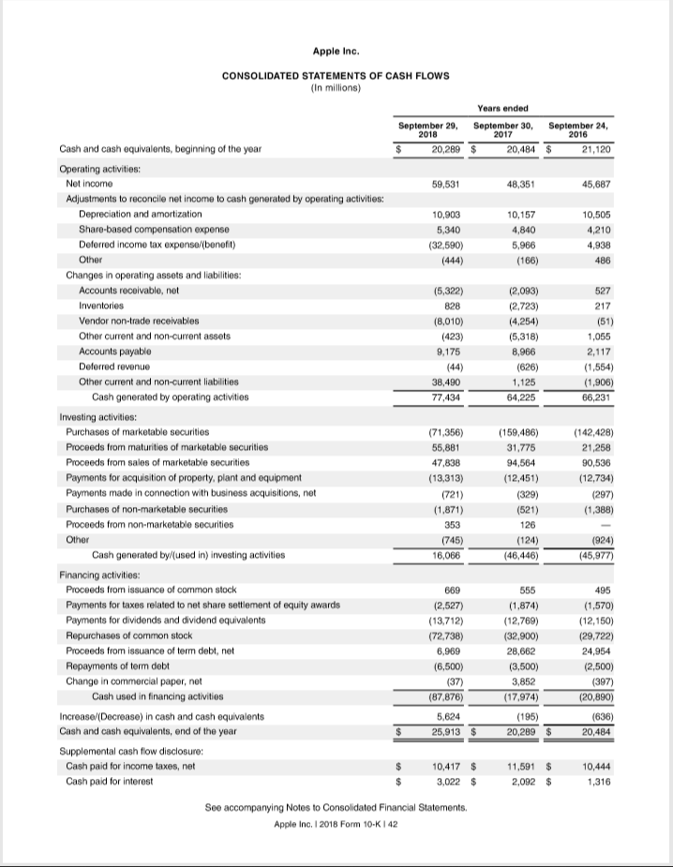
Source: https://media.cheggcdn.com/media/c46/c465f747-977f-419a-a8fd-f70bba2615ee/phpLO2WwW.png
From the above two diagrams of statements of cash flow of Wal-mart stores and Apple Inc, we can see that in the year 2016, the cash flow for wal-mart stores was $15, 080 million. The factor behind the positive cash flow lies on the cash gained from operation activities which reflects a good sign for investors. The net operating activities were $27,389. It means that the operations at Wal-mart stores are generating money that can be used to purchase new inventories. However, when you compare it with the cash flow from Apple Inc, you find that Apple is much better as they have a cash flow of $45,687. This is much bigger from what Wal-mart store had initially. They show that they can buy more inventories as they had net cash generated from operating activities of $66,231. Even these amount ease the investors' mind as cash is plenty to cover loan expenses. For that reason, Apple Inc appears to be a stable company against Wal-mart stores.

References
Arnold, A. G., Ellis, R. B., & Krishnan, V. S. (2018). Toward effective use of the statement of cash flows. Journal of Business and Behavioral Sciences, 30(2), 46-62.
Bradbury, M. (2011). Direct or indirect cash flow statements? Australian Accounting Review, 21(2), 124-130.
Davis, A. B. (2015). Statement of cash flows: History, practice, and the classroom. Advances in Accounting Education, 17, 101.
Krishnan, G. V., & Largay III, J. A. (2000). The predictive ability of direct method cash flow information. Journal of Business Finance & Accounting, 27(1‐2), 215-245. Retrieved from: https://onlinelibrary.wiley.com/doi/abs/10.1111/1468-5957.00311
Livnat, J., & Zarowin, P. (1990). The incremental information content of cash-flow components. Journal of Accounting and Economics, 13(1), 25-46. Retrieved from: https://www.sciencedirect.com/science/article/abs/pii/016541019090066D.
Ormiston, A., & Fraser, L. M. (2007). Understanding financial statements. Pearson/Prentice Hall. Book: https://ugeb.pw/book-understanding-financial.pdf

